**LISTS:**

list1 = ['physics', 'chemistry', 1997, 2000];

list2 = [1, 2, 3, 4, 5, 6, 7 ];

print ("list1[0]: ", list1[2])

print ("list2[1:5]: ", list2[1:3])

list = ['physics', 'chemistry', 1997, 2000];

print ("Value available at index 2 : ")

print (list[2])

list[2] = 999999;

print ("New value available at index 2 : ")

print (list[2])

list1 = ['physics', 'chemistry', 1997, 2000];

print (list1)

del (list1[2]);

print ("After deleting value at index 2 :")

print (list1)

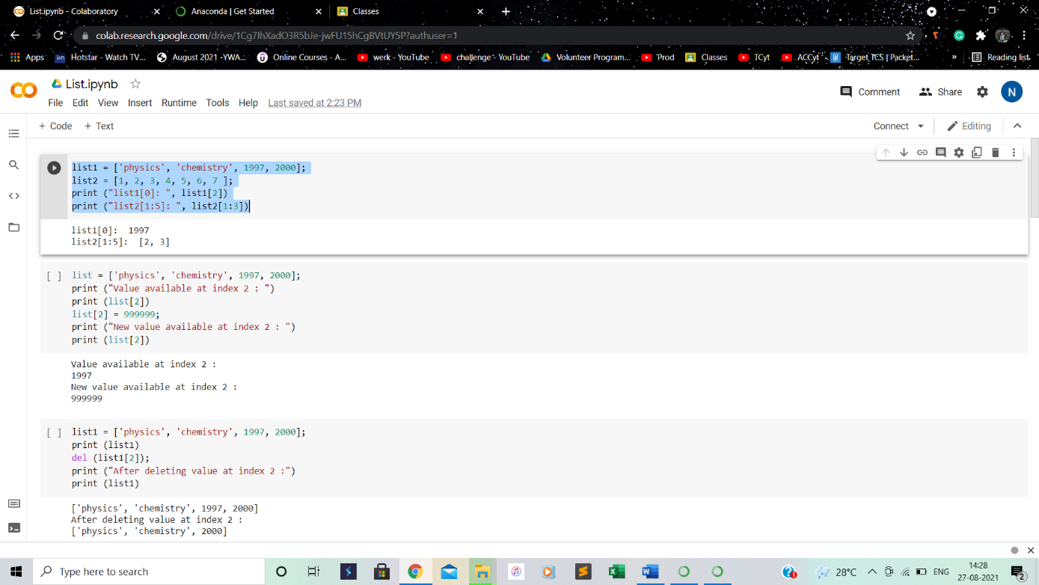

list1, list2 = [123, 'xyz', 'zara'], [456, 'abc']

print ("First list length : ", len(list1))

print ("Second list length : ", len(list2))

aList = [123, 'xyz', 'zara', 'abc'];

aList.append( 2009 );

print ("Updated List : ", aList)

aList = [123, 'xyz', 'xyz', 'abc', 123];

print ("Count for xyz : ", aList.count('xyz'))

print ("Count for zara : ", aList.count('zara'))

aList = [123, 'xyz', 'zara', 'abc', 123];

bList = [2009, 'shabnam'];

aList.extend(bList)

print ("Extended List : ", aList)

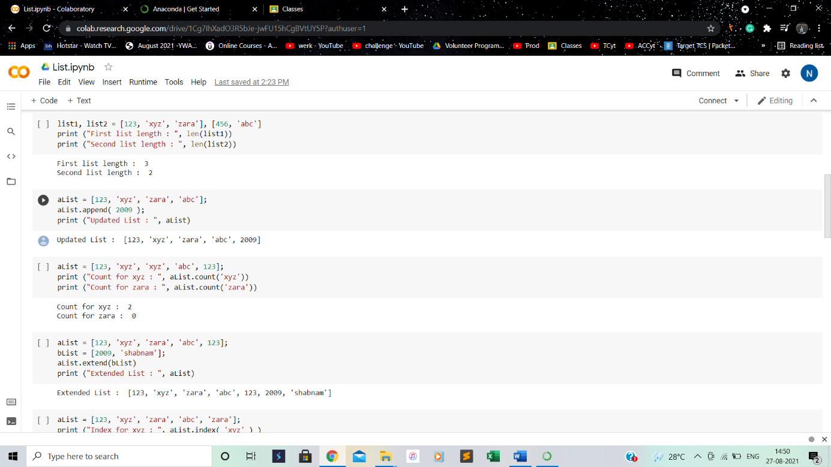

aList = [123, 'xyz', 'zara', 'abc', 'zara'];

print ("Index for xyz : ", aList.index( 'xyz' ) )

print ("Index for zara : ", aList.index( 'zara' ) )

aList = [123, 'xyz', 'zara', 'abc']

aList.insert( 2, 2009)

print ("Final List : ", aList)

aList = [123, 'xyz', 'zara', 'abc'];

print(aList)

print ("List after popping last element : ", aList.pop())

print(aList)

print ("List after popping element from mentioned index: ", aList.pop(2))

print(aList)

aList.insert(1, 2009)

print(aList)

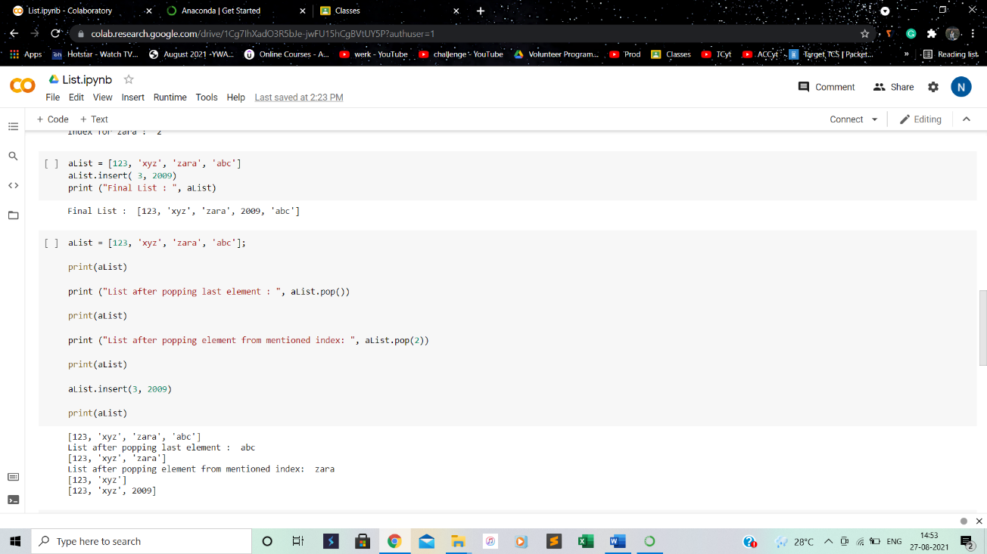

aList = [123, 'xyz', 'zara', 'abc', 'xyz'];

aList.remove('xyz');

print ("List : ", aList)

aList.remove('abc');

print ("List : ", aList)

aList = ['shabnam', 'rohit', 'zara', 'abc', 'neha'];

aList.reverse();

print ("List : ", aList)

aList = ['naveen', 'shabnam', 'sonia', 'ali', 'neha'];

aList.sort();

print ("List : ", aList)

aList = ['naveen', 'shabnam', 'sonia', 'ali', 'neha ,'123'];

aList.sort();

print ("List : ", aList)

